Correlations and ANOVA Analysis
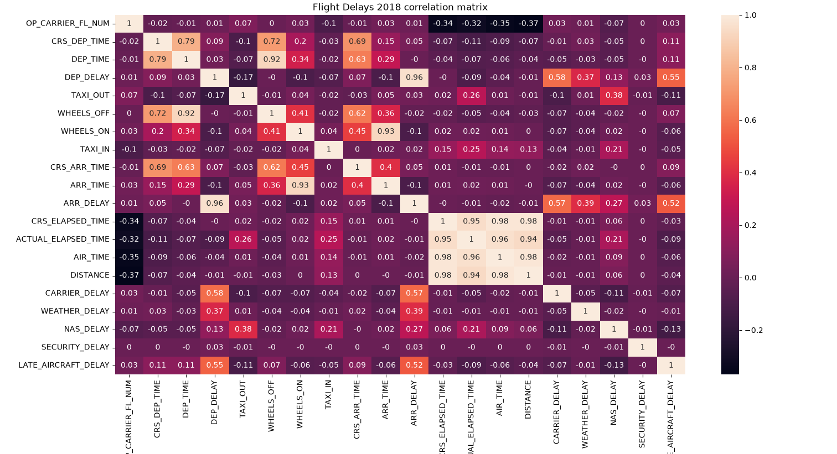
I made a correlation matrix for all the numeric columns in the Flight Delays 2018 data. The strongest relationship is between departure delay and arrival delay at 0.96, so flights that leave late almost always arrive late. The columns about flight length are also tightly linked. Scheduled elapsed time, actual elapsed time, airtime, and distance are all between 0.94 and 0.98, which makes sense because longer distances take longer to fly. Some of the time columns are related too, like departure time and wheels off at 0.92, and wheels on and arrival time at 0.93. For the delay causes, carrier delay (0.58) and late aircraft delay (0.55) have the strongest links to departure delay. Weather delay is lower at 0.37. They show nearly the same pattern for arrival delay. Security delay is close to 0 with everything, so it doesn’t seem related to any of the other columns. Flight number has a weak negative link to distance and airtime, about -0.35, but flight number is just an ID, so I wouldn’t read much into it. A correlation only shows that two columns move together. It doesn’t prove one causes the other.
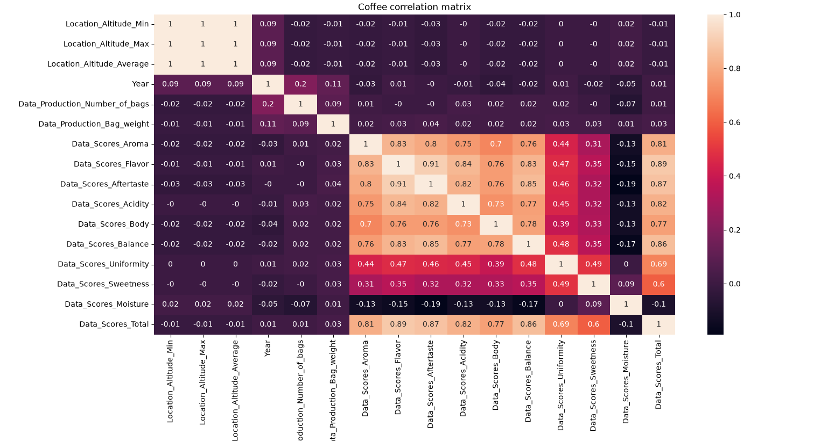
Next is the correlation matrix for the numeric columns in the coffee data. The three altitude columns (min, max, and average) all have a correlation of 1 with each other, so they measure basically the same thing. The taste score columns are strongly related to each other. Flavor and aftertaste are the highest pair at 0.91, and flavor and acidity (0.84), aftertaste and balance (0.85), and aroma and flavor (0.83) are also high. Total score is most linked to flavor (0.89), aftertaste (0.87), and balance (0.86), which makes sense because it is built from the other scores. Sweetness and uniformity are the weakest of the taste scores. Sweetness is only around 0.31 to 0.35 with aroma, flavor, aftertaste, acidity, body, and balance. Moisture has small negative links to the taste scores, from -0.13 to -0.19. The production columns, year, and altitude are all close to 0 with the taste scores, so where the coffee was grown and how many bags were produced don’t seem to be tied to how it scored.
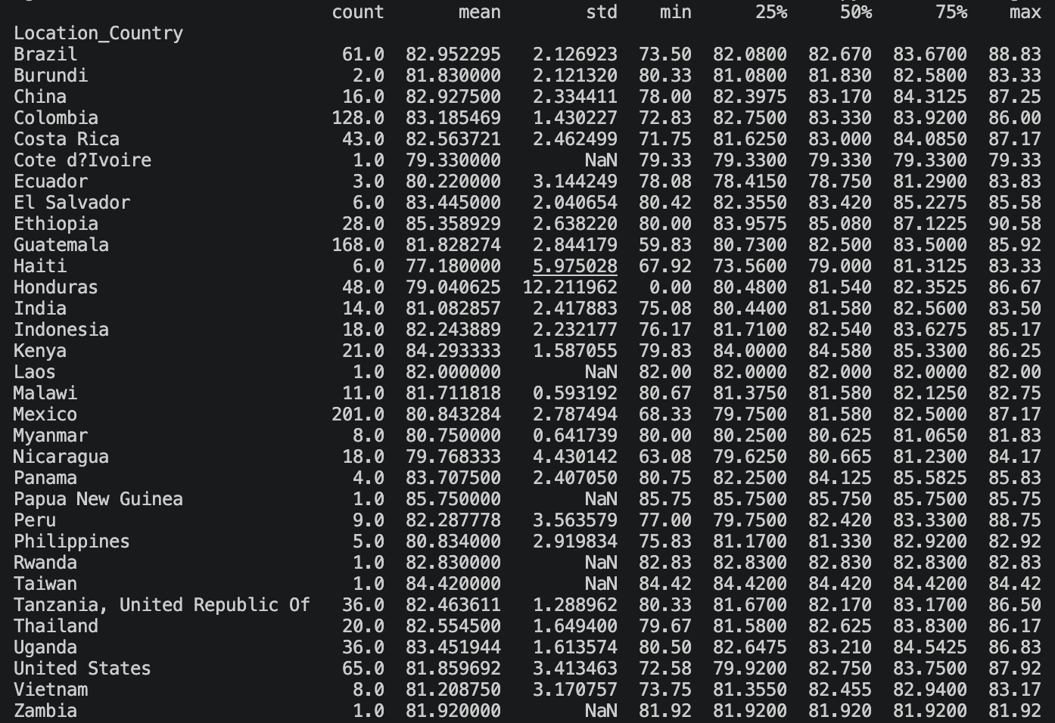
Before the ANOVAs, I looked at the mean and spread of Data_Scores_Total for each country to choose my groups. I used total score because it sums up the other quality scores. I left out countries with only 1 or 2 rows, like Burundi, Laos, and Rwanda, since they are too small to compare. I also left out Honduras because it has a minimum score of 0.00, which looks like a bad data point and pulls its mean down to 79.04. For the group with no difference, I picked Brazil (mean 82.95, 61 rows), China (82.93, 16 rows), and Thailand (82.55, 20 rows). Their means are within 0.4 points of each other. For the group with a difference, I picked Ethiopia (85.36, 28 rows), Colombia (83.19, 128 rows), and Mexico (80.84, 201 rows). Their means are about 2 to 4.5 points apart.
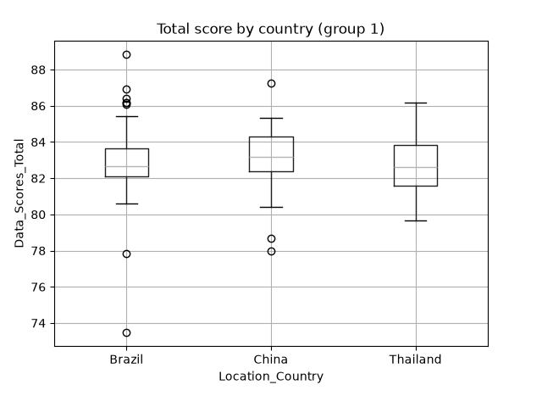
For the first ANOVA, I picked Brazil, China, and Thailand because their total scores looked alike. The boxplot shows their medians are all around 82.5 to 83, and their boxes cover about the same range. Brazil has several outliers at both the high and low ends, and China has a few low ones, but the middle of each group lines up.
I ran an ANOVA on Data_Scores_Total for Brazil, China, and Thailand. The null hypothesis is that the average total score is the same in all three countries. The F-statistic is 0.29, and the p-value is 0.75. Since the p-value is above 0.05, I fail to reject the null hypothesis. There is no statistically significant difference in the average total score between these three countries. This matches the boxplot, where the medians and boxes lined up closely.
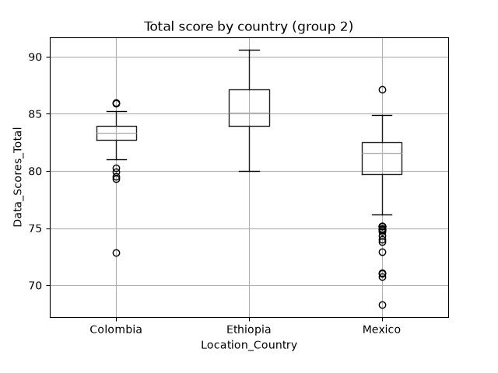
For the second ANOVA, I picked Ethiopia, Colombia, and Mexico because their total scores looked different. In the boxplot, Ethiopia’s median is highest at about 85. Colombia is in the middle at about 83, and its box is very narrow. Mexico is lowest at about 81.5, and it has the widest spread, with a lot of low outliers down to about 68.

I ran an ANOVA on Data_Scores_Total for Ethiopia, Colombia, and Mexico. The null hypothesis is that the average total score is the same in all three countries. The F-statistic is 67.58, and the p-value is 1.39e-25, which is far below 0.05. I reject the null hypothesis. There is a statistically significant difference in the average total score between these three countries. This matches the boxplot, where Ethiopia’s box sits highest and Mexico’s sits lowest. The ANOVA only tells me that at least one country is different. It doesn’t say which pairs differ, so I used the boxplot and the group means to see that Ethiopia is the highest and Mexico is the lowest.

